SOP for SmartTech Database Implementation

To download MySQL https://dev.mysql.com/downloads/installer/

- Database Creation
Database Name: smarttech_db
CREATE DATABASE IF NOT EXISTS smarttech_db;
USE smarttech_db; -> to select which schema I want to start with.

- Creating Core Tables
The following tables were created:

Table name | Description
branches | Stores company branch information
departments | Departments within each branch
employees | Employee details and their associated departments
customers | Customer contact and address details
products | Products and services sold or maintained
sales | Sales transaction data
maintenance_requests | Service and maintenance request tracking

- Relationships Between Tables (ERD)
One-to-Many:
branches → departments
departments → employees
customers → sales, maintenance_requests
products → sales, maintenance_requests
employees → sales, maintenance_requests
All relationships were defined using FOREIGN KEY constraints.

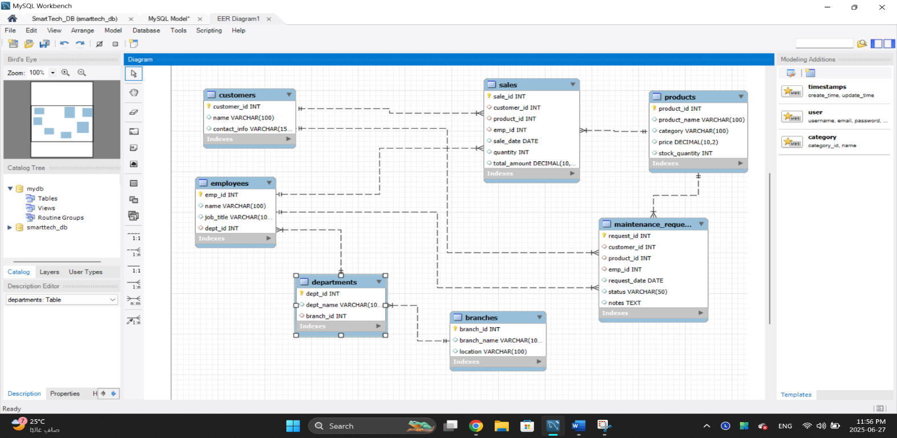
- Inserting Sample Data
Test data was inserted into:
Customers, products, employees, departments, branches, sales, maintenance_requests

- Creating Users

Query with Explanation:

CREATE USER IF NOT EXISTS 'sales_user'@'%' IDENTIFIED BY 'Sales123!';
IF NOT EXISTS -> prevents an error if the user already exists.
sales_user -> name of username/account.
@'%' -> Allows the user to connect from any host/IP.

Hint: @’localhost’ (ex: 127.0.0.1) -> Allows the user to connect only from the same machine/server where MySQL is installed.
IDENTIFIED BY 'Sales123!' -> Sets the password for the user.

How to create user in MySQL Workbench?

Step 1: Open MySQL Workbench

Step 2: Create a New Connection
On the MySQL Workbench Home Screen, click the "+" (plus icon) next to “MySQL Connections”, A window titled “Setup New Connection” will appear.

Step 3: Fill in Connection Details
Field | Description
Connection Name | Choose any name (e.g. Sales_user)
Connection Method | Select: Standard (TCP/IP)
Hostname | For Cloud: use your EC2 Ip  For Local: use localhost or 127.0.0.1
Port | Default is 3306
Username | Enter the database username (e.g., sales_user)
Password | Click “Store in Vault…”, then enter the user's  password-> Sales123!

Step 4: Test the Connection
Click the “Test Connection” button.
If successful, a message will appear:
“Successfully made the MySQL connection.”
Step 5: Save the Connection
Click “OK” to save the connection.
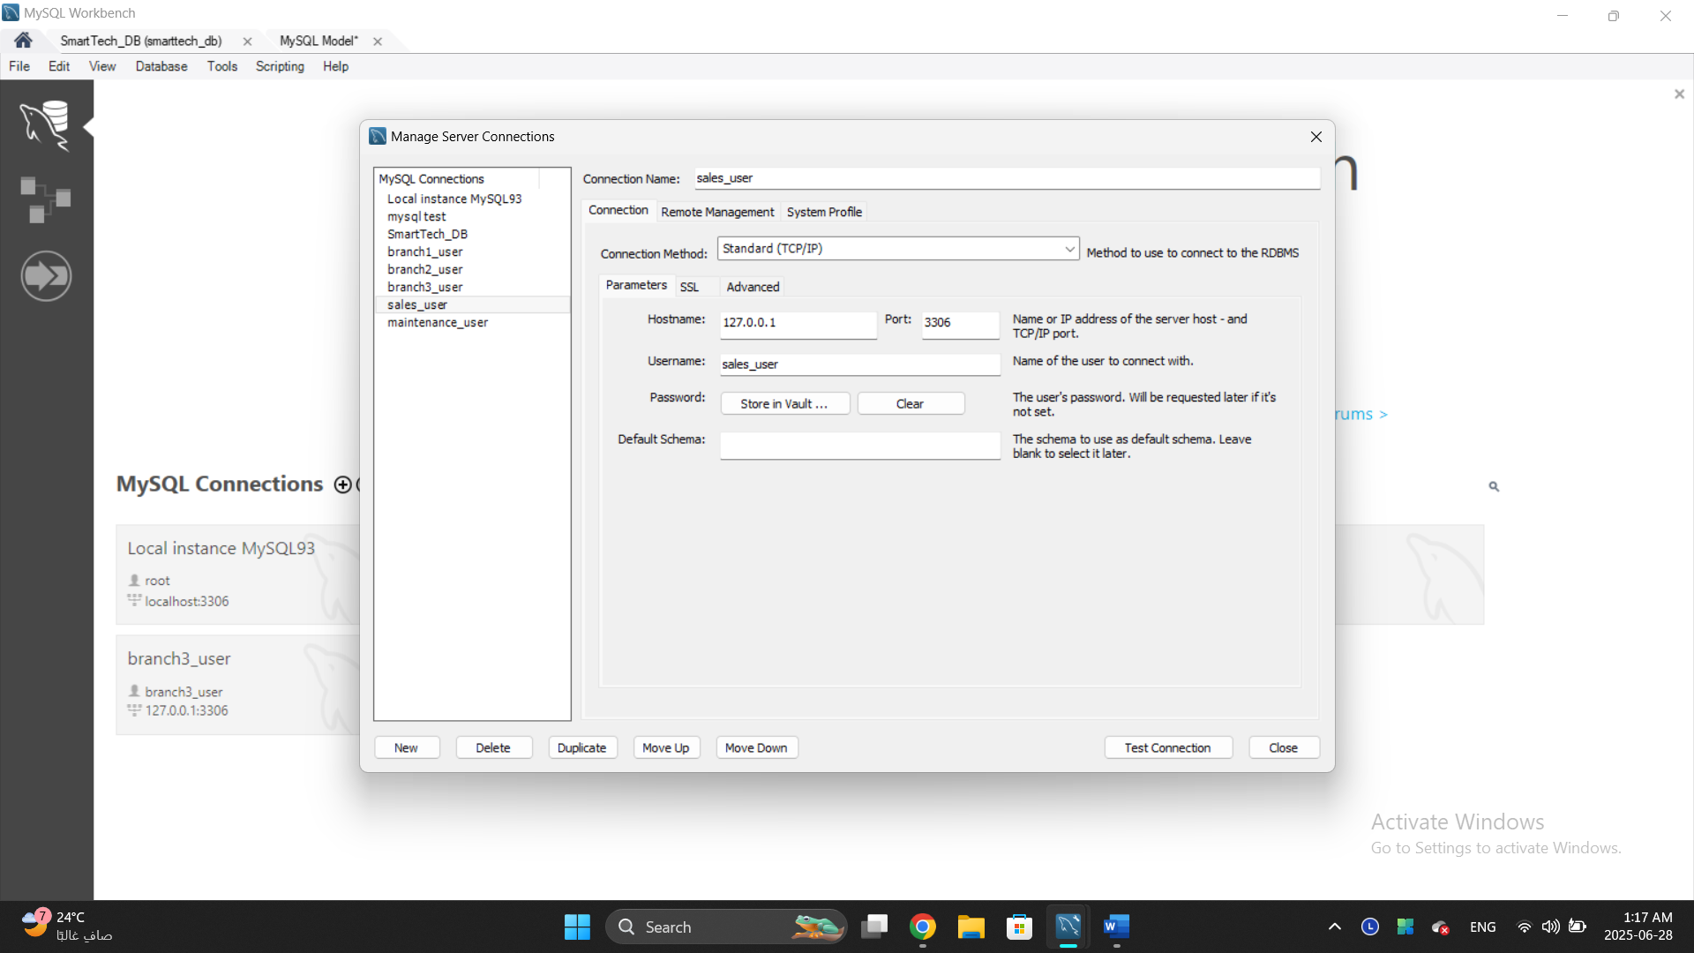

- User Privileges Assigned
EX: sales user -> GRANT SELECT, INSERT, UPDATE ON smarttech_db.sales TO 'sales_user'@'%';
GRANT SELECT ON smarttech_db.products TO 'sales_user'@'%';

- Privileges Testing
Logged in as each user and ran-> SELECT CURRENT_USER ();

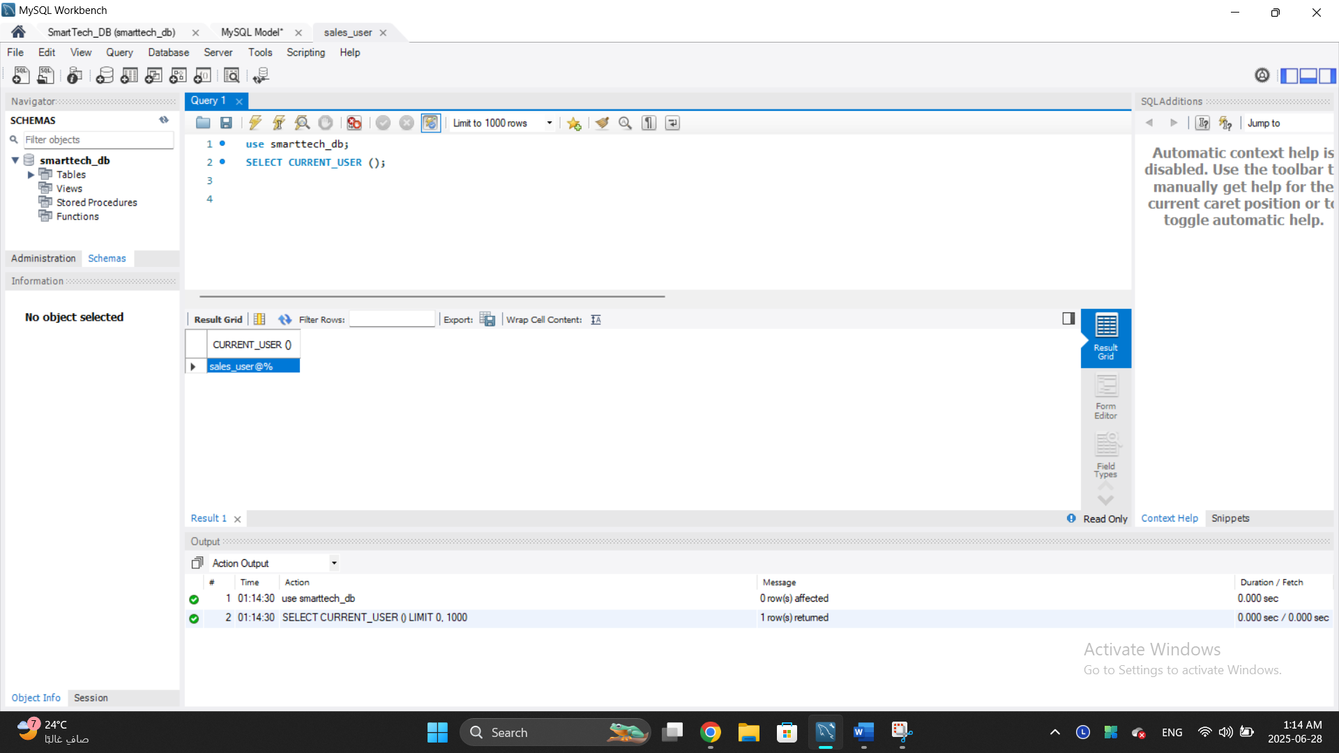
Verified access:
- Users could only run the commands they were granted.
- Unauthorized actions triggered proper error messages.

Ex: sales user can select on smarttech_db. products
Cannot select on smarttech_db. Branches
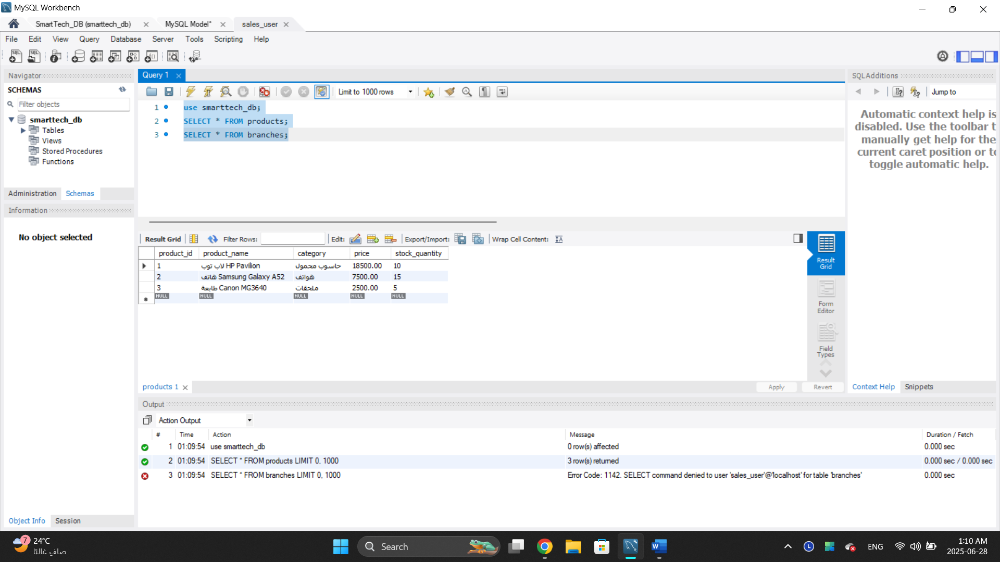
Query with Explanation:

SELECT e.name AS employee_name, COUNT(r.request_id) AS total_requests
FROM employees e
LEFT JOIN maintenance_requests r ON e.emp_id = r.emp_id
GROUP BY e.name
ORDER BY total_requests DESC
LIMIT 5;
----------------------------------------------------------
SELECT e.name AS employee_name, COUNT(r.request_id) AS total_requests

- SELECT: Specifies the columns to display in the result.
- e.name: Refers to the employee's name from the employee’s table.
- AS employee_name: Creates an alias for better readability in the result.
- COUNT(r.request_id): Counts how many maintenance requests are linked to each employee.
- AS total_requests: Gives the count column a clear, readable name.

FROM employees e
- Sets the base table for the query (employees).
- e is an alias (short name) for employees, used for convenience in the rest of the query.

LEFT JOIN maintenance_requests r ON e.emp_id = r.emp_id
- Joins employees with maintenance_requests table.
- LEFT JOIN: Ensures all employees appear in the result, even those who have no maintenance requests.
- ON e.emp_id = r.emp_id: Links the two tables based on matching employee IDs.

GROUP BY e.name
- Groups the results by each employee.
- Required when using aggregate functions like COUNT () to summarize data.

ORDER BY total_requests DESC
- Sorts the output by the number of requests.
- DESC: Means descending order (from highest to lowest).

LIMIT 5
Restricts the result to only the top 5 employees with the highest number of maintenance requests.

Feature | Primary Key | Foreign Key
Purpose | Uniquely identifies each row in a table. | Creates a link between two related tables.
Location | Defined in the main table (the parent). | Defined in a child table to reference the parent.
Uniqueness | Must be unique and not null. | Can have duplicates and can be null (in some cases).

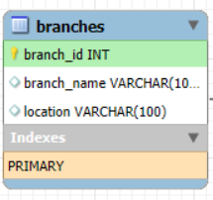
CREATE TABLE branches (
branch_id INT AUTO_INCREMENT PRIMARY KEY,
branch_name VARCHAR (100),
location VARCHAR (100)
);

CREATE TABLE departments (
dept_id INT AUTO_INCREMENT PRIMARY KEY,
dept_name VARCHAR (100),
branch_id INT,
FOREIGN KEY (branch_id) REFERENCES branches(branch_id)
);

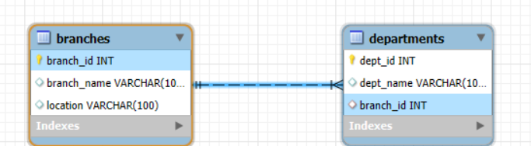

My Query

